TC-CMS-007
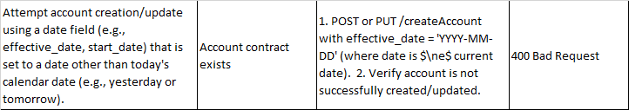
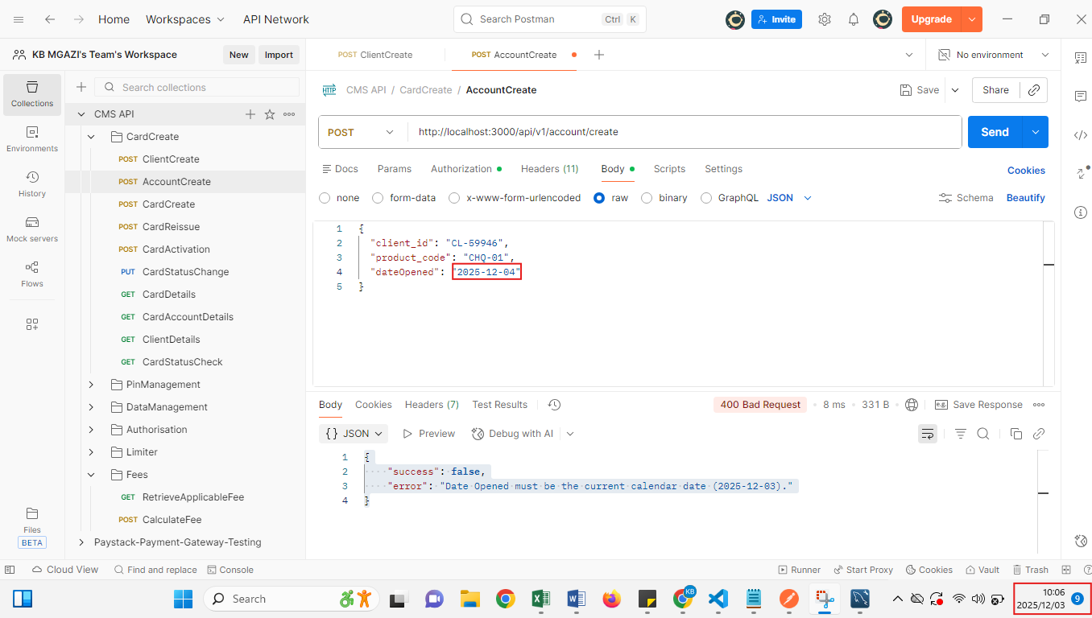
Request:
{
"client_id": "CL-59946",
"product_code": "CHQ-01",
"dateOpened": "2025-12-04"
}

Response:
{
"success": false,
"error": "Date Opened must be the current calendar date (2025-12-03)."
}

